MUSIC

CD

- Star Wars: The Force Awakens CD by John Williams
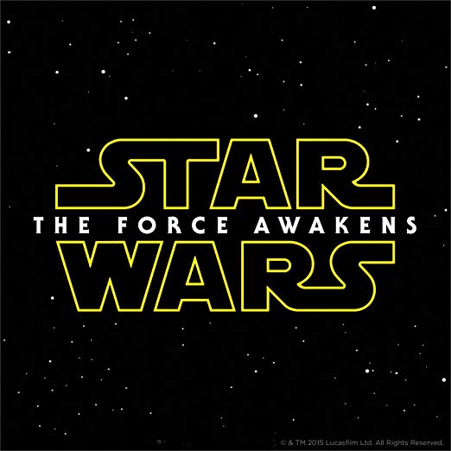

- Explain how and when you’d use the cd
I would use this CD when we are talking about the solar system. The CD would be playing when the students transition from station to station. Hearing the music will indicate to the students that it is time to move to a different station. When the music stops, it should let the students know they need to be ready to begin work at the next station. Playing background music during the transition time helps students reduce the feeling of anxiety and stress. Music helps students regulate their emotions, as well as enhancing the way the students process language and speech.

Song Selection for Singing
      - We are the Planets,” The Solar System Song by StoryBots

We can see the whole Solar System from here.
I think we can hear it from here too.
We are the planets of the Solar System
Different sizes for everyone
The music never ends
We are such good friends
And we all orbit the sun

SUN
Here comes the Sun rapping first on this track, from the beginning
I'm the center of the solar system, planets be spinning
Around me, so hot, I'm roasting, ya see?
Now I pass the mic to the planet closest to me

MERCURY
Mercury! The smallest planet, small as Earth's moon (MOON: "Yo!")
I get super-hot and cold and I spin very slow

VENUS
I'm Venus! I've got mountains and volcanoes that spray
I'm the same size as Earth but spin the opposite way

EARTH
Yeah, I'm Earth, I'm the home to every boy and girl
(Sung by Stars) Such a beautiful, beautiful world

MARS
I'm Mars, the red planet, I've got deserts and ice
And I've got two moons - nice - that's like one moon, twice!

JUPITER
I'm Jupiter! the biggest planet, I'm humungous, gargantuan
I spin the fastest, rap the fastest, plus I'm handsome, BAM SON!

SATURN
Oh please, I'm Saturn, check out my beautiful rings
Made up of billions of rocks, dust, and other things

URANUS
I'm Uranus, I say that with pride, okay, I lied
I'm embarrassed cause I'm the only planet lying on its side

NEPTUNE
I'm Neptune, I'm cold, dark, windy and mysterious
I'm very stormy, so bring an umbrella - I'm serious

ALL PLANETS
We're the planets in the Solar System
Different sizes for everyone
The music never ends
We are such good friends
And we all orbit the sun
Well, we are done exploring the Solar System.
I am thirsty. Let's explore the rest of the Milky Way Galaxy.

      - §112.14. Science, Grade 3, Beginning with School Year 2010-2011. Science (8). Earth and space. The student knows there are recognizable patterns in the natural world and among objects in the sky. The student is expected to: (B) describe and illustrate the Sun as a star composed of gases that provides light and thermal energy; (D) identify the planets in Earth's solar system and their position in relation to the Sun.

      - §117.12. Music, Grade 3. Music (4). Creative expression. The student creates and explores new musical ideas within specified guidelines. The student is expected to: (A) create rhythmic phrases through improvisation or composition; (B) create melodic phrases through improvisation or composition; and (C) create simple accompaniments through improvisation or composition.

      - The learner will be able to use this song in my classroom in many ways. The song and video will provide a fun and engaging activity that provides the students with a unique way of learning and memorizing the order of the planets in the Earth’s solar system and the characteristics of the sun and the planets. I would not only use this video as a summary of my lesson, but I would make it interactive for the students. Since there are eight planets, I would assign two to three students (depending on the number of students in my class) to the same planet until all the students have a planet. Then, I would instruct each student group to take their lines from the song which correspond to their assigned planet (or sun) and ask them to add on to their line(s) or change it around in a way that they find they can remember. I would tell the students that they can even come up with hand motions to go along with the song. I will write on the whiteboard one or two more characteristics of each planet on the board for the students can look at to add to their song part. Once everyone finishes their part of the song, we will make a circle, and a mic will be passed back and forth. We will all sing the first few verses of the song together, and then I will hand the mic off to the first group, the Sun, and let them sing their part as a group, and then they will hand the mic off to the next group, Mercury, and so on. At the end, all the planet groups will sing the last verses together. This a fun way of learning and helps the students memorize the order of the planets and a few of the characteristics of each planet.

Musical Instrument

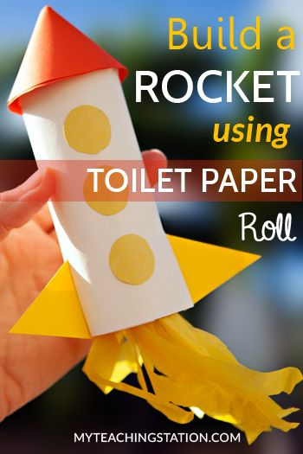
- “Rocket Shaker”
- The materials that each student needs to complete the musical instrument is an empty toilet paper roll, 3 sheets of construction paper (orange, white, and yellow) glue sticks (or stapler), scissors, colorful beads, and yellow tissue paper.
- Step by Step Instruction
- Cut the white paper using the length of the toilet paper roll to wrap it around it.
- Tape a round piece of paper to the top of the toilet paper roll to close it off. (This will be provided to make sure it is cut to the correct size).
- Cut out a 2" radius circle from the orange paper and wrap it around to make a cone.
- Glue the cone on top of the toilet paper roll
- Cut out three small circles from the yellow paper to make the windows of the rocket.
- Cut out two small triangles to make the base for the rocket
- Make two small cuts (1" long) at the bottom of the toilet paper and insert the triangles.
- Glue the yellow circles on the toilet paper roll.
- Put a handful or two of beads inside the bottom of the toilet paper roll
- Tape another piece of paper to the bottom of the toilet paper roll to close off the bottom and hold the beads in place. (This paper will be cut and provided by the teacher to ensure the correct size.)
- Add the yellow tissue paper streamers at the bottom.

- §117.12. Music, Grade 3. Music (2) Creative expression/performance. The student performs a varied repertoire of music. The student is expected to: (A) sing or play a classroom instrument independently or in groups; and (B) sing songs from diverse cultures and styles or play such songs on a musical instrument.

- §110.14. English Language Arts and Reading, Grade 3, Beginning with School Year 2009-2010. (13) Reading/Comprehension of Informational Text/Expository Text. Students analyze, make inferences and draw conclusions about expository text and provide evidence from text to support their understanding. Students are expected to: (A) identify the details or facts that support the main idea; (B) draw conclusions from the facts presented in text and support those assertions with textual evidence; (C) identify explicit cause and effect relationships among ideas in texts; and (D) use text features (e.g., bold print, captions, key words, italics) to locate information and make and verify predictions about contents of text.
- The learner will learn about the first rocket launched to the moon. The learners will realize the important role the rocket ship played for astronauts to travel into space in order to discover things about our universe. The first lunch of the rocket ship to the moon will spark curiosity in the learners that will lead them to a lifelong pursuit of learning and discovery.

Lesson Plan

Engagement/Connecting to Prior Knowledge | To get my students excited for the lesson I will ask them if they have seen fireworks shoot up high into the sky? Who wants to travel higher than fireworks and explore space? After asking the questions, “I will say, wow, I think we should go to space now. Come and gather around the rug in a circle and grab our space helmets we created the other day.” The students would be seated. I would explain that everyone is going on a rocket ship for a trip to the moon. I will tell the students to start the countdown “10, 9, 8, 7, 6, 5, 4, 3, 2, 1 BLAST-OFF! As we say “Blast off” the students would stand and jump up. I will then announce to the students to return to their seats. Once they are seated, I will ask ‘Who is ready to learn about the first rocket launched to the moon?”
Teaching Point | Today we will be learning about the first rocket launched to the moon. We will create our own model of a rocket ship and write a paper about the article we read as a class about the first rocket launched to the moon.
Teach | Listen to me as I explain to you what we are going to be doing.  First, I will read the article about the first rocket launch to the moon out loud to the class. (We will all have a copy of the article on our tables.) Follow along!  Then, I will ask you to tell me what interesting facts you learned from the article. It could be the material of a rocket ship, how fast it got to the moon or any interesting facts about the launch.  Then, I will write what the students say on the whiteboard.  Next, the students at their table should reread the article and generate more facts they learned from the article and write down their facts on their paper. I will remind the students to remember that there is no right or wrong format. I will tell the students to make sure a noun and a verb are in each sentence. I will remind the students that every sentence needs a punctuation mark. Also, I will tell them to include all the factual information about the rocket ship we wrote on the whiteboard in their paper.  Then, once the class finishes their papers, each student will make their own Rocketship.  I will place the materials everyone needs on their tables.  They will be instructed to follow the directions under the musical instrument.  Each person will make their own rocket ship.  Finally, once the assignment is complete, we will share with our class our rocket ship and read our paper out loud. Once everyone who volunteered to share shared, we will all use our “Rocket Shakers” to shake to the beat to the rhythm of the solar system song we learned previously.
Active Engagement | Now it’s your turn to try it out...  I will begin reading the article to my students. I will stop after each paragraph and asked what interesting facts they got out of that portion of the article. I will ask students to highlight it on their paper so we can put it on the whiteboard after we finish reading. Then once they told me enough facts, I will write them on the whiteboard. Then, I will give my students a few minutes to start thinking about what to write on their own paper. I will remind them to reread the article. If the students are not writing after a few minutes, I will ask them if they need further gaudiness. I will tell them that there is no right or wrong answer. I will reinforce to my students that a noun and verb and a punctuation mark needs to be in each sentence. This assignment is for you all to gain a better understanding of how a rocket is made, how it gets to space, and what the first rocket launched to moon ship was like. After they all finished writing. I will tell them the instructions on how to make the rocket ship again. Once the students finish their craft, they will conclude the activity by reading their paper to their table groups and showing off their Rocketship. Finally, as a class, we will all use our “Rocket Shaker” to beat to the rhythm of the song about the solar system.
Link/Check for understanding | Today we learned about rocket ships and about the first rocket launched to the moon. We learned how to put information from the article into our papers. We sparked thrill and curiosity when we all pretended we were in a rocket ship that was about to take off! We can look back at the musical instrument we made. We made a rocket ship shaker! Who can share with me their paper and rocket ship they created? I will allow some students to stand up and read their papers and present their rocket ship shakers to the class. At the end, all students will stand use their rocket shaker in beat to the rhythm of the song about the solar system we learned previously.

1 Visiting Live Performer: Cody Johnson

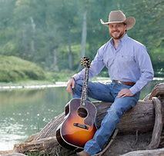
I chose Cody Johnson as my visiting live performer. Cody Johnson attends the Cowboy Church in Montgomery, Texas on Sundays when he is not on the road performing. Before he became a professional country singer, he competed in rodeos as a bull rider and worked as a prisoner supervisor at the Huntsville prisons. He never attended college, but his high school music teacher encouraged Cody to sing as a profession. Cody grew up not knowing what he wanted to pursue as a career and explored many types of jobs. At church, Cody is very involved with the children and teaches them how to rodeo. I would invite Cody Johnson to my class by emailing his agent at chas@red11music.com or by calling him at (512)-373-8511. I would explain to his agent that Cody would be providing my students with a once and a lifetime experience to meet a professional cowboy and singer, and his example would be an encouragement to each of them to express their creativity and try new things. I would ask him to play a song on his guitar, explain the different chords on the guitar, and sing to them a song over the solar system. After Cody sings, I would have my students sing along with him and pull out the guitars, and each student will try out the chords they learn by taking turns on the guitar. Before Cody visited the class, I will encourage my kids to ask questions, listen actively, follow his instructions, and be respectful. I will already have my students split into groups with a guitar in each group. The students in each group will share one guitar. The groups will be based on the number of guitars I have in the music center. We would come up with a list of questions that the students could ask Cody. I chose Cody Johnson because he loves children and is eager to help people. He loves sharing his talents of singing and playing the guitar with others. This experience will be beneficial for my students because they will understand that famous people are not really different from them, and they will witness a real performer singing a song. The students will also have the privilege of being instructed by someone who sings and plays guitar professionally and being provided useful tips in singing and playing that Cody learned over time.

TEKS

§117.112. Music, Grade 3, Adopted 2013.
Creative expression. The student performs a varied repertoire of developmentally appropriate music in informal or formal settings. The student is expected to:
(A) sing or play classroom instruments with accurate intonation and rhythm independently or in groups;
(B) sing or play a varied repertoire of music such as American folk songs and folk songs representative of local cultures independently or in groups;
(C) move alone or with others to a varied repertoire of music using gross motor, fine motor, locomotor, and non-locomotor skills and integrated movement such as hands and feet moving together;
(D) perform simple part work, including rhythmic and melodic ostinati, derived from known repertoire; and
(E) interpret through performance new and previously learned music symbols and terms referring to tempo and dynamics, including mezzo piano and mezzo forte.

§110.5. English Language Arts and Reading, Grade 3, Adopted 2017.
(b) Knowledge and skills. (1) Developing and sustaining foundational language skills: listening, speaking, discussion, and thinking--oral language. The student develops oral language through listening, speaking, and discussion. The student is expected to: (A) listen actively, ask relevant questions to clarify information, and make pertinent comments; (B) follow, restate, and give oral instructions that involve a series of related sequences of action; (C) speak coherently about the topic under discussion, employing eye contact, speaking rate, volume, enunciation, and the conventions of language to communicate ideas effectively; (D) work collaboratively with others by following agreed-upon rules, norms, and protocols; and (E) develop social communication such as conversing politely in all situations.

Music center floor plan and center information

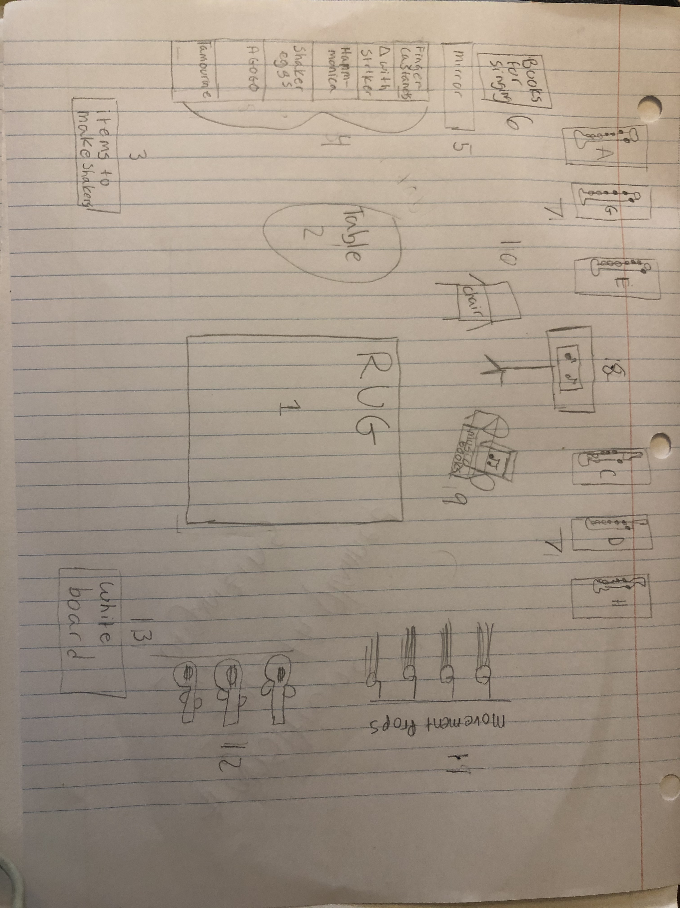
- Rug - The rug is where the students can gather and play with different musical instruments on the rug.
- Tables – Students can sit at the tables to make a shaker, read music books, play an instrument, or just talk with friends.
- Shaker Station – This is where the supplies to make a shaker will be. Students can create their own musical shakers from this station.
- Storage – The storage will have bins labeled that will have certain musical instruments in each one. For example, the bin with the tambourine will be labeled “tambourine” and have a picture of what a tambourine looks like. The bins will be labeled tambourine, agogo, shaker eggs, harmonica, triangle with striker, and finger castanets. These are all musical instruments the students can create music with and learn how they are used.
- Mirror – The mirror is for students can see their self-playing the musical instruments.
- Box of Books for Singing – These books will be full of songs that the students can sing from.
- Music Notes Poster Walls – The poster walls will help students remember different chords/notes of certain instruments.
- Music Stand – The music stand is for the students to lay down a music book on it and play a song on the instrument by reading the music notes from the book.
- Music Books – The music books are for students to read the chords/notes and play an instrument.
- Chair – if a student wants to sit on a chair.
- Movement Props – Movement Props are for the students to create dance moves and sing.
- Guitars – The guitars will be used when Cody Johnsons comes to the classroom. It is also for students to play and learn the chords. The students can create music with the guitar.
- Whiteboard – The whiteboard is for two students to enjoy practicing writing music notes on the board.

Skills I want the students will develop-

I want the students to develop their creativity, free-thinking, critical thinking, self-confidence, and curiosity. I want students to know and believe that mistakes are okay. My goal is for students to be able to have fun while learning. I want them to memorize the order and characteristics of the planets in a creative way. This may involve creating a song that is fun to remember. I want the students to be respectful to the materials and their classmates. I want the students to learn how to ask other classmates for assistance and trust one another. I want my students to use the right tone and voice level, as well as being able to come to a consensus on how to solve a task given to them. I want my students to work together in order to develop their social skills. I want the students to feel comfortable and confident in their writing and their craft so they can share their projects with the class. Also, I want my students to encourage one another and provide respectful and helpful feedback if a student asks another student for advice. Through all the projects, the students should develop a deeper knowledge about the Earth’s solar system and how one gets to space.

Basic materials needed for the center-

Tambourine, agogo, harmonica, triangles with striker, finger castanets, mirror, books for singing, posters of music notes/chords, music stand, chair, music books, movement props, construction paper, beads, beans, guitar, whiteboard, expo markers, and a radio.

The purpose of the music center is for students to express themselves using music. The center is an important place for students to experience playing different instruments and hear the different sounds each one makes. The center provides opportunities students may never receive at home because many homes do not have any type of instrument. The music center is also a perfect place for students to experience playing all sorts of different types of instruments. It is important to have guidelines in the music center that provide a framework but still allows the students to be creative. Students will enjoy participating in musical activities.

Guidelines-

- Students will respect one another and will not draw or mess up each other’s rocket ship.
- Students will respect the teacher’s rules.
- Students will follow the all the school and classroom rules.
- Students will respect all the materials and use them properly.
- Students will handle the instruments with care and not play roughly with them.
- Students will each be allowed to use one instrument at a time before pulling another one out.
- Students will make sure the instruments and the supplies are properly put back in the right place after using them.
- Students will be respectful to one another in the center regarding the loudness of the instrument they decide to use.
- Students will use the appropriate amount of glue, beads, and paper when working.

Assessment instrument –

Formative- Teacher will observe the students before the activity when asking the students about the who knows how to get to space. The teacher will also observe the students when the volunteer comes up to the front and shares his or her paper and rocket ship with the class. While doing the assignment, the teacher will observe the students asking each other for help about the information in the article. The teacher will observe the students to make sure they fully understand the assignment and follow the directions.

Summative- The teacher will access the student’s paper as a summative assessment. The teacher will use the rubric below to make sure the students present all the facts on the whiteboard and if the students and used proper sentence structure. The teacher will also be assessing the students by making sure they followed directions carefully and that their work is legible.
Rubric |  |  |  | Bonus Points
Points | 3 | 2 | 1 | 3
All Facts were mentioned in paper | All facts from the whiteboard about the first rocket launch to the moon was mentioned | Five or more facts form the whiteboard about the first rocket launch to the moon was mentioned | Three or less facts from the whiteboard about the first launch to the moon was mentioned | If the students added additional facts from the article in their paper.
Sentence structure | Each sentence contained a noun and a verb with the correct punctation mark. | More than half of the sentences contained a noun and a verb with a punctation mark. | Less than half of the words contained both a noun and a verb long with a punctation mark.
Legible | The paper is easy to read and is written in a neat fashion. | The paper is a little difficult to read and some what neat. | The paper is difficult to read and messy.
 |  | Total Points=

